**Ideation Phase**

**Define the Problem Statements**

|  |  |
| --- | --- |
| Date | 19 September 2022 |
| Team ID | PNT2022TMID27274 |
| Project Name | Customer Care Registry |
| Maximum Marks | 2 Marks |

**Customer Problem Statement Template:**

Create a problem statement to understand your customer's point of view. The Customer Problem Statement template helps you focus on what matters to create experiences people will love.

A well-articulated customer problem statement allows you and your team to find the ideal solution for the challenges your customers face. Throughout the process, you’ll also be able to empathize with your customers, which helps you better understand how they perceive your product or service.

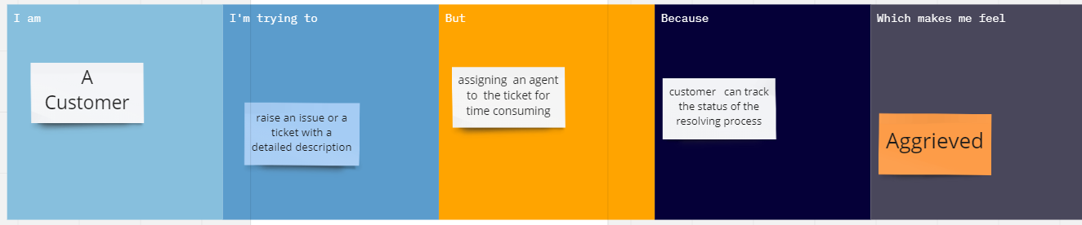

|  |  |  |  |  |  |
| --- | --- | --- | --- | --- | --- |
| **Problem Statement (PS)** | **I am (Customer)** | **I’m trying to** | **But** | **Because** | **Which makes me feel** |
| PS-1 | Customer | Raise an issue or a ticket with a detailed description | It seems solving the issue is time consuming | the communication between customer and agent is not better | Worried |
| PS-2 | Customer | Raise an issue or a ticket with a detailed description | It seems assigning an agent to the ticket is time consuming | Email notification and status tracking is not fast | Annoyed |